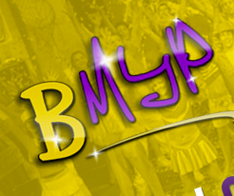
BRISTOL MUSICAL YOUTH PRODUCTIONS APPLICATION FORM

Surname
First Names
Date of Birth
Address

Postcode
Email Applicant
Email Parent
Tel Number Parent
Tel Number Applicant
School Name
Attach photo Here
Are you involved in any other theatre club?.................................................................
 | Grade Achieved | Working towards | Name and address of teacher/school
Dance: Ballet  Tap  Modern  Jazz | ………………………………….  ………………………………….  ………………………………….  ………………………………… | …………………………………  …………………………………  …………………………………  …………………………………
Singing

Instrument
(Please specify)
Theatre/Television/School Plays/Eisteddfod experiences: Please continue overleaf if necessary
…………………………………………………………………………………………………………………………………………………………………………………………………………………………………………………………………………………………………………………………
Signature............................................................................................. Applicant
Signature..............................................................................................Parent/Carer
Name (s) of parent (s) / Guardian ......................................................................................................

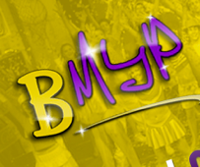
BMYP APPLICATION FORM PART 2
AUTHORISATIONS
Contact details in case of emergency for
Emergency contact 1 Name
Relationship
Phone number
Emergency contact 2 Name
Relationship
Phone number

Any relevant health conditions: ……………………………………………………………………….

Does your child take any regular medication?
Please specify …………………………………………………………………………………………………..

Up to the end of school Year 11, we need permission for your child to be:

- Licenced
- Photographed for publicity, programmes and videos
- Collected from rehearsals
- Allowed out for short periods during day rehearsals

COMMITMENTS

- I agree to sell at least 25 tickets per show
- I agree to take part in a rota of helpers at Friday and Sunday rehearsals, and during show week
- I agree to help with my child’s costumes and any other aspects of the production – including set painting, tea making, hair and make-up, continuity and chaperoning
- I agree to pay subscription charges on time
- Members are required to attend ALL rehearsals to which they are called unless there is a very good reason
- Full membership rules and regulations, to be adhered to, can be found in our rule book
- There will be a charge of £50 for gaps in membership to hold open a child's place

I …………………………………………………………… parent/guardian of ……………………………………………………….

agree to the above conditions of membership to Bristol Musical Youth Productions.
I agree to inform the membership secretary immediately of any changes to the information supplied

Signed ………………………………………………………………………………………………………………
You can fill these out on the computer and simply send an email back saying ‘I give permission to use my e-signature’ Please send your completed form to bristolmusicalyouth@gmail.com or you can print out and send it to Mrs B Tucker, 19a Heywood Rd, Pill, North Somerset BS20 0ED

